SURGICAL SERVICES
1400 Senate Ave Suite 103 Red Oak, IA 51566
(712) 623-7240 Fax (712)623-7244

DR. GRASS PREP INSTRUCTIONS FOR COLONOSCOPY – SUTAB

Your procedure is scheduled on __________________ with Dr. Grass

Medication to stop: Aspirin _____ Plavix_____ Coumadin_____ NSAIDS_____ Eliquis_____
Pradaxa_____ Xarelto_____ Fish Oil_____ Other__________________

Two days before the colonoscopy:
- Make sure you have picked up your Sutab from the pharmacy. Read these instructions again and call the office if you have any questions.
- NO raw fruits or vegetables. NO popcorn, nuts, corn, bran/fiber bars, cereals, or meats. Eat light foods, soups, pudding, ice cream, yogurt and oatmeal – all soft foods. Avoid thick cuts of meat i.e.: chicken, steak, and pork. You may eat deli sliced meats and hamburger.
- Drink plenty of fluids.
- Diabetic Patients: Please call your primary care provider for insulin adjustments.

One day before the colonoscopy:
- NO solid food; NO alcohol
- Clear liquids all day.
  - Upon waking, drink at least 8 ounces of clear liquids every hour until bedtime. This is in addition to the colon prep. Always avoid RED, PURPLE, or BLUE colored liquids, Jell-O, or popsicles.
  - As a rule – if you can see through it, you can drink it.
  - Clear fruit juices (apple or white grape juice)
  - Water, Tea, or Coffee (without cream)
  - Kool-Aid, Gatorade, or PowerAde
  - Clear soup, broth, or bouillon
  - Popsicles, hard candy, soda pop, Jell-O
- At 5pm, open 1 bottle of 12 tablets. Fill the provided container with 16 ounces of water (up to the fill line). Swallow each tablet with water. Wait 1 minute between tablets. Drink the entire amount over 15-20 minutes. If you become uncomfortable, take the tablets and drink the water a slower pace. Approximately 45 minutes after the last tablet is swallowed, fill the provided container a second time with 16 ounces of water (up to the fill line) and drink the entire amount over 30 minutes.

- Approximately 30 minutes after finishing the second container of water, fill the provided container with 16 ounces (up to the fill line) and drink the entire amount of water over 30 minutes.

- Continue to drink clear liquids the rest of the evening until bedtime.

The day of the colonoscopy:

2nd dose will be due 5 hours prior to check in time. Repeat steps as directed above. The surgery department will be the one to notify you of this time. Their number is 712-623-7174.

- NO solid foods; NO alcohol.
- Take your morning medications with small sips of water, except: __________, ___________, ___________.
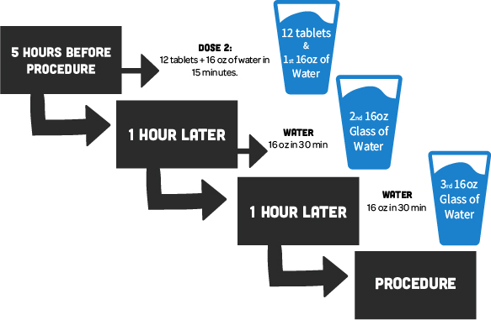
- Five (5) hours prior to check in time ______ am, take the 2nd bottle of 12 tablets and repeat previous dose. Important: you must use all tablets and water at least 2 hours before you colonoscopy.
- AFTER FINISHING THE WATER, NOTHING ELSE BY MOUTH.

Check in at the Emergency Department registration desk at _______ am.
Please have your driver’s license and insurance available.

You will need a driver if you will be receiving sedation for your procedure.

Frequently Asked Questions
Question: What if I feel like I am going to vomit if I drink another glass, OR, what if I start to vomit while taking the prep?
Answer: Stop prep for 30-45 minutes until symptoms subside, then resume.
Question: What if I take all of the prep and I do not have a bowel movement?
Answer: Wait one (1) hour. If still no stool, you will need a Fleets enema. This can be purchased over-the-counter at any pharmacy. If still no results, call the doctor who will be performing your colonoscopy.
Question: What if I have rectal discomfort?
Answer: You may apply a petroleum-based product or diaper rash ointment to the rectal area if you experience discomfort from frequent stools.
Question: Does my driver have to stay with me during the procedure?
Answer: If your driver does not wish to remain in the lobby, a contact number may be given to the nursing staff. Typically, the driver can return two (2) hours after they drop you off.
Question: Can I eat after my procedure?
Answer: Usually you can resume your normal diet unless otherwise instructed.
Question: Will I be asleep for my procedure?
Answer: Yes, you will be given anesthesia. You will be comfortable and unaware of the procedure. The medications given to you are designed to decrease your awareness and will affect your ability to remember the event.

